EFFECTS OF SIMULATED ACID RAIN ON IN VITRO
POLLEN PERFORMANCE OF PYRUS COMMUNIS L. AND
MALUS SYLVESTRIS MILLER
AYKUT TOPDEMiR and NAZMi GUR
Firal University, Science Faculty Biology Department, 23 169. F.lazig, Turkey, e-mail: alopdemirfagmail.com; nazmigur@gmail.com
Abstract. Successful fruit set depends on several reproductive processes including pollen germination and lube growth processes. Pollens of/V/'W connnniiis L. and Mains sy/veslris Millet flowers have been exposed lo different concentrations of simulated acid rain solutions in range of pHs 6.0 to 2.8. Brawbakcr Kwack medium was used for pollen germination. According to the results obtained, germination rate and pollen tube length for each plant at least has been affected at pi I 6.0. Pollen germination and tube length significantly decreased with increasing acidity. The decrease of these rales for Mains sytvestris Miller was 99.44% for pollen germination and 99.68% lor lube length: and for Pyrus communis I... 96.23% for pollen germination and 96.75% for tube length at a pH of 2.8. It has been shown that acidity has a higher effect on blocking Ma/us sylveslrii Miller pollen performance in vitro comparative with Pyrus communis L.
Key words: Acid rain, apple, pear, pollen, germination, tube growth
Rezuniat. Efectcle ploii acide simulate asupra starii sporilor de polcn de Pyrus communis si Mains fylvestris .Miller. Sueccsul frueiificarii depindc de o serie de proccsc reproductive ce includ proccsclc de germmare si crcstcrc a tubului polinic. Sporii de polcn apartmand speciilor Pyrus communis I. si Mains svlvesiris Miller au tost expusi la difcrile concentratii ale unor solutii de ploi acidc simulate, cu pli-u! variind inlrc 6.0 si 2.S. Penim germinarea polcnului a lost folosil tin mediu Brawhaker Kwack. Confonn re/ultatclor obiimite. rata de germinare si lungimea tubului polinic au Cost ecl mai putin afcclaic la tin pi I de 6.0 At.it rata de germinare a polenului, cat si lungimea tubului polinic s-au micsoral considerabil ndata cu crcstcrca acidilatn. Scadcica aeestor rale la Mains svlvcsms Miller an lust dc 99,44% in ceea cc priveste germinarea polenului si dc 99.68% pentru lungimea tubului polinic. iar pemru Pyrus communis L, a fost dc 96,23% pentru germinal ia polcnului si de 96,75% pentru lungimea lubultn polinic la un pll de 2.8, Accasta a dcrnonstral ca aciditatea are un elect mult mai inhibitor asupra starii polcnului in vitro la \4alus ivlvcstris Miller comparativ cu Pyrus communis L.
Cuvintc cheic: ploaie acida. mar. par, polcn. germinalic. tub polinic
Introduction
Acid rain is a serious environmental problem in the world. Studies investigating the effects of acid rain on the vegetative parts of plants, labeled these effects as biochemical (relationships between enzymes, proteins, amino acids, respiration and transpiration), microscopic (stonia destruction, epidermis and changes on the mcsophyll layer) and macroscopic (necrosis, chlorosis and growth retardation) (Woliers and Martens, 1987; Shumejko et al., 1996; Youngmi et al., 2006; Sanl'Anna-Santos et al., 2006; lie et <.//., 201 1). Acid ram is also effective on the generative pans of plains in addition to the vegetative pans. Pollen with male gametophytcs among flowering plants is the principal part in this regard (Murdy, 197')). Pollen, reported as a bio-indicator of environment pollution by many researchers, is greatly affected by negative environmental (actors (Woltcrs and Martens, 1987: Larrival et. al., 1996) Acid rain is one of the factors that negatively

'■;
■
i

58
Aykui Topdemir and Nazmi Our
affect in vitro pollen germination and tube growth (Sidhu, 1983; Ryn el a/., 1980; Hellani el a!., 1987; Munzuroglu et a!., 2003).
This study aims to determine the effects of simulated acid ram on pollen germination and tube lenght, and thus establish the negative effects of acid rain on the pollen growth of apple and pear plants, which are of huge economic value for Turkey.
Materials and methods
Study material included the pollen of pear {Pynis communis I..) and apple {Mains sylvestris Miller) plants in Elazig Province and the surrounding counties. Brewbaker fCwack culture was used as a medium for the germination of the pollen (Shivanna and Rangaswamy, 1992). II:S(\< (Merck) and deionized water was used for preparing simulated acid rain solutions. Dcionised water (pll 6.5) has been used as control.
pH concentrations were pll 6.0, pH 5.8, pll 5.6, pll 5.4. pi I 5.2. pH 5.0. pH 4.8, pH 4.6, pH 4.4, pH 4.2. pH 4.0, pll 3.8. pH 3.6, pH 3.4, pll 3.2. pH 3.0, and pH 2.8. pH measurements have been clone with digital pll meter (Extcch PI 1100). Sterile 3 micro-slides were prepared (breach pll solution (2 for experimental group. 1 for control group). A 50 ul culture solution was dripped to 2 various areas on each slide. I hen 50 ul pll solutions (experimental groups) and 50 ul deionized water (control group, CG) were added onto the slides. Pollens on anther were homogeneously cultivated m the culture medium using a sterile syringe under a stereomicroscope. Petri dishes (15 cm diameter) with a moist (liter paper lining the lower plate served as an improvised humidity chamber. Two glass rods were placed in parallel, about 4 cm apart, on the moist filter paper to facilitate the handling of the pollen cultures.
Then, the Petri dishes were settled in the incubator (Ileraus HI 2) at 22 ±2 "C. Bach germination medium was fixed with 10% cthanol after 3 hours to close the lamella. Germination percentages and tube lengths of the pollens were determined under the light microscope (Olympus. BX51) by the method of Shivanna and Rangaswamy (1992). All experiments were repeated three times and results were statistically analyzed by calculating variance and the standart error (Sx) of the mean. Statistical analysis was performed based on SPSS (version 10.0) program. In order to detect the significance of differencics (p 0.01 or p 0.05) of variables, a multiple comparison (LSD) test was performed.
Results
The effects of acidity on in vitro germination and tube lengths in the pollen of apple {Mains sylvestris Miller) and pear (Pvnis communis L.) plants are given in Figs. 1-4.

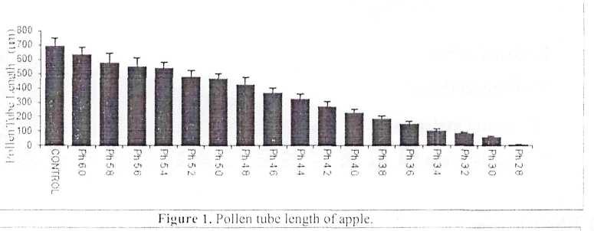
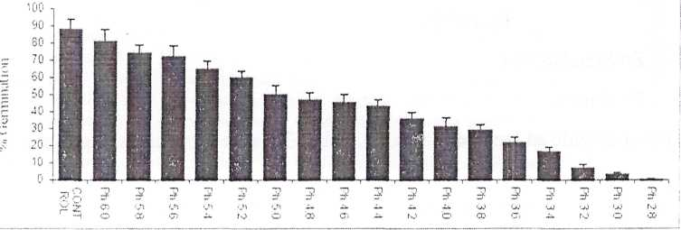
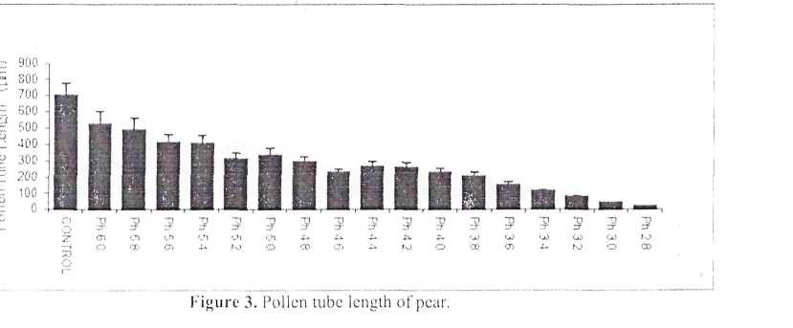
The anthropogenic impact upon Black Sea region biodiversity \ 59
Figure 2. ['ollen germination rates of apple.

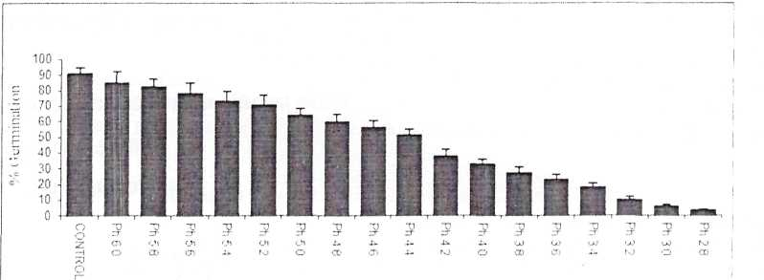
160
Aykut Topdemir and Nazmi Gur

Figure 4. Pollen germination rates of pear.
The germination rate of the pollen of apple plant was determined as 88.2% in the control group (pH 6.5). The closest pll value (pH 6.0) to the control group was measured as 81.54% germination rate, and no significant (p 0.05) decrease was observed in germination rate. However, a regular decrease was determined in germination rate as the acidity degree increased. Germination rate was (bund to he negligibly low (0.49%) at pll 2.8. The comparison of the control groups and the highest and lowest acidity degrees indicated that 99.44% of decrease was observed at pll 2.8. and 7.57% of decrease was determined at pll 6.0.
In terms of the tube length in the apple plant, it was measured as 6^{C})2 mn in the control group, and the difference was not significant at pll 6.0 and pH 5.8, the closest values to control group: however, the tube length significantly decreased with increasing acidity degree. These values arc 81.2 um at pi I 3.2. 55 urn at pll 3.0, and 2.2 um at pli 2.8. Considering the tube length of pollen, a comparison of the control group and tube length at pll 2.8 revealed 99.68% of decrease and statistically important (p 0.01) and the comparison with pll 6.0 indicated a 2.02 % decrease.
Pollen of the apple plant was negatively affected by high acidity both in terms of germination and tube length. The best germination and tube growth were observed in pll 6.0. closest to the control group.
The germination rates of the pollen of the pear plant indicated that there was 91.19% germination in the control group (pll 6.5). Depending on the increase in acidity, the germination rate was observed to decrease. This rate was 85.14% at pll 6.0 - the closest to the control group, and 82.34% at pH 5.8. These were not statistically significant (p 0.05). The germination rate was 6.34% at pH 3.0, and when it was compared to the control group, there was a 93.04% decrease in germination rate, and when 3.43% of the germination rate measured at pll 2.8 was compared to the control group, there was a 96.23% decrease (p 0.01).
The investigation of pear plant in terms of tube length demonstrated that tube length was 702.9 um in the control group (pll 6.5). 632.4 j.tm at pH 6.0. the closest and lowest pll to the control group, and 22.8 mn at pll 2.8. the furthest and highest acidity value from pi 1 control group. A comparison of tube length with the control group revealed a 10.01% decrease at pll 6.0. and a 96.75 % decrease at pll

161
2.8. As can be understood from these measurements, increasing acidity degree mostly inhibited the pollen tube length in the pear plant.
The comparison of inhibition rates in both plants demonstrated 96.23% in the pear plant and 99.44% in the apple plant at pH 2.8, and thus the apple pollen was concluded to be more affected. A comparison of pollen tube lengths showed that the apple plant was more affected by high acidity with a 99.68% decrease compared to pear plant.
Discussion
Acid rain is among the most important environmental factors affecting plant reproductive processes such as pollen germination, pollen tube growth and fruit-set. The current study, which examined pollen response to simulated acid rain from pi I 6.0 to 2.8, shows very clearly that pollen lube germination and tube growth processes negatively effected from .simulated acid rain.
Various studies have reported this subject for pollens of different plant species (Nadaka el al., 1980; Wertheim and Cracker. 1988: Ren/.om and Viegi, 1 99 1; Rmallo. 1 992: Shan et a!., 1 996; Sharma et a/., 1 993).
In the study of Bcllani et al.. apple pollen was subjected to acidity degrees at pll 5.6. 4.0 and 3.0. Apple pollen was examined for liveliness, germination and lube length. In parallel with the present study, pollen germination and tube length were observed to significantly decrease with increasing acidity degree (Bellani et al., 1987). Munzuroglu et al. (2003) obtained similar results in Mains sylvestris Miller cv. Golden pollen.
The present study demonstrates that simulated acid rain negatively affected the pollen germination and tube growth of economically important Mains sylvestris Millcrand i'vnis comnnmis L. plants. Mains sylvestris Miller is more sensitive to simulated acid rain than Pyrus comnnmis L. In conclusion, considering the level of the exiting pollutant load of rain in the air, there is a serious cause of concern that pollen performance will be greatly reduced, with negative effects on apple and pear production, tithe acidity of rainfall continues to rise.
References
Bellani, I.. M.. Rinallo. ('., Muccifora, S.. Gori. 1-.. 1987. Effects of simulated acid rain on polcn physiology and ultraslructurc in the apple. Env. Pol. {)S (3): 357-362.
He. M.. De-ming, O.. Ju. W.. 2(11 I. Effects of simulated acid ram on main nutritional indicators of three leafy vegetables. Chem. Res. in Chin. Univ. 11 (3): 397-401.
I.arrival. C. Bocquel C, jarrcau. M C. C. Verhille. A. M.. 1996, I'olcn: bio-indicaior of pollution. J. (if Acr, Sei. 27 (8): 227-228.
Munzuroglu. O.. Obek, E., Geckil, H.. 2003. Effects of simulated acid ram on the pollen germination and pollen mbc growth of apple (Mains sylveslris Miller cv. Golden). Ada Biol. Hun. 54 (1):95-103.
Murdy. W. Effect of SO; on sexual reproduction in Lepidiwn virginiciwi 1. Originating from regions with different SO; concentrations. Bol. (in::. 140: 299-303. Nakada, VI., Fukaya K... Takcshita. S.. Wada, Y., 1980.
Effects of inorganic components in acid rain on lube elongation of camellia polen.. Environ. Pol 21 (I): 51-57. Ren/oni. (i. ('.. Vicgi, L, 1991. In vitro sensitivity Pimispinaster and I'.pinea pollen grains to differenl pll values. Ann. Bol. Fenn. 28: 135-142' Rinallo. ('.. 1992. Effects of simulated acid rain on the foliage and fruit yield of Mains domestica Borkh.
J. Hon. Sci. 67: 553-559.
Ryn. V. D. M. Jacobscn. J. S., Lassoic. J. P.. 1986. Effects ol idity on the in vitro pollen germination and tube elongation in lour hardwood species.
Sant'Anna-Samos. B. P., Silva, L C, Azevedo. A .'• Silva, I.. A. M.. Aguiar,
R. 20(16. Effects of simulated acid n the foliar micrcmorphologx and anatomy of tree tropical species. Env and Exp B
Shan. Y., Feng, '/-.. Izuta. 'I.. Aoki, M.. TolaThe iridix idua! and combined effects of ozone and simulated acid rain on growth. ga> exchange rate and water-use efficiency of Pinut armandi Franch Enwxm. Pol 91 335-361
Singh. O S.. Klhanra. S.. 1993. Effect of acid rain on pollen germination and pollen tube in groundnut (Arachis hypogea L). Indian ./. Ecol. 20: 1 17-1 20. Rangaswamy. N- S.. 1992.

