A Comparison Study of Rail Fault Detection Methods in the Literature

Canan Tastimur¹, Mehmet Karakose² and Erhan Akin³
^{1,2,3}Firat University, Departure of Computer Engineering, Elazig, Turkey
{ctastimur¹, mkarakose², eakin³}@firat.edu.tr

Abstract— Rails are one of the most important components of railway transportation. It is needed that the rails can be observed at regular interval in order to ensure the safety of railway transportation, prevent the disruption of transportation, and avoid accidents. To be inspected of rail surface by using manual techniques, both damages the rail surface and leads to disruption of railway transport. Rail profile analysis methods that utilize contactless image processing techniques are available in the literature in order to avoid these problems. This paper presents a comparison of rail defect detection methods that are available in the literature. These methods in the literature have been compared in terms of feasibility, performance, accuracy, elapsed time, and image processing techniques used. The advantages and disadvantages of these methods relative to each other are examined in this article.
Keywords—Rail defects; Image processing techniques; Defect detection; Rail surface analysis

Introduction
Railway transportation is considered as one of the safest transportation types all over the world. The railroad transportation is spreading rapidly. As railway transportation has become widespread throughout the world, the importance given to the maintenance and safety of railways has also increased. Railways are composed of several components. The most important component is rail. Train accidents happened every year in the world due to heavy task. And the train accidents resulted in serious destruction of property and injury or death of passengers and crew members [1]. Many of the railway transport accidents happen because of driver’s tiredness, bad weather conditions, and defective rail components, etc. To prevent these accidents, importance is attached to the detection of faulty regions in the tracks, and other rail components.
Safety of railroad transportation can be enhanced by utilizing intelligent systems that provide additional information about the exact location of the train, its speed and upcoming obstacles. The rails face more and more risk of damage with the increase of speed [2]. Therefore, the rails should be closely inspected for internal and surface faults. Rail profile analysis using manual methods both damages the rail surface and temporarily disrupts railway access. For this reason, rail profile analysis for railway transportation has been done using contactless image processing techniques. Methods, which detect the rail failures by means of contactless image processing techniques, are available in the literature. Sambo et al. [3] presented a novel algorithm that detect rail surface rolling contact fatigue (RCF) damage and automatic incorporation in a crack growth model recommended an important contribution to the development of modern techniques for non-destructive rail inspection.
Mao et al. [4] developed a sensor fault detection scheme for rail vehicle passive suspension systems, using a fault detection observer, in the presence of uncertain track regularity and vehicle noises that are modeled as external disturbances and stochastic process signals. Faghih-Roohi et al. [5] proposed a deep convolutional neural network solution to the analysis of image data for the detection of rail surface defects. They compared the results of different network architectures characterized by different sizes and activation functions. Hu et al. [6] detected uneven brightness and noise, the heavy rail surface defects, according to the characteristics of heavy rail surface defects, based on the mathematical morphology of multi-scale and dual-structure elements. Compared with the traditional edge detection operators, the results show that their method owns strong anti-noise performance, can detect the small defect edge accurately under noise.
Shen et al. [7] investigated the feature extraction of the turnout defects based on the bogie acceleration measurements. They established the normal turnout model and faulty turnout model based on SIMPACK and then analyzed the acceleration signal in time- frequency domain. The results showed that the power spectral density (PSD) and all the frequency-domain features are useful for detecting the poor fit defect of the switch point. Vijaykumar and Sangamithirai [8] developed a method that detect the surface defect on railheads. The proposed method used Binary Image Based Rail Extraction (BIBRE) algorithm to extract the rails from the background. The extracted rails were enhanced to achieve uniform background with the help of direct enhancement method. The enhanced rail image used Gabor filters to identify the defects from the rails. Thresholding was done based on the energy of the defects.
Yaman et al. [9], took images from two cameras placed at different angles on the established experimental structure. The images were preprocessed using the Otsu method. Then, rail surfaces are detected using Canny edge extraction and Hough transformation algorithms. The rail surfaces detected in the images taken from the two cameras are combined to detect failures on the track surface. The accuracy of the proposed method is enhanced by images taken from two different cameras. Block diagram of this study is given in Fig. 1. Tastimur et al. [10] offered Morphological feature extraction based image processing algorithm in order to determine the breakdowns of rails. The rail was determined through applying the image processing methods and Hough transform to the received images
- Block diagram of rail failure detection in the literature [9].
of rail. Headcheck breakage, apletilic and undulation of defects was determined by proposed method. Faulty regions was determined through extracting features of regions in images by applying Morphological operations to detected rail images. Jie et al. [11] represented present a new vision based inspection technique for detecting special Rolling Contact Fatigue (RCF) defects that particularly occur on rail head surface. Wei et al. [12] proposed a rail defect detection method based on vibration acceleration signals. Molodova et al. [13] developed a method that the focuses on the early detection of short surface defects called squats and uses axle box acceleration (ABA) measurements.
In this paper, we have compared several methods that exist in the literature to each other. It is examined rail fault detection algorithms, the performance of these algorithms, and the advantages and disadvantages of these algorithms in relation to each other. Moreover, these algorithms have been compared in terms of feasibility. Comparative tables are presented in the following sections.

Rail Surface Defects
Failures that have occurred in the rails can be expressed as wear, scour, breakage, undulation, headcheck, and oxidation [14]. Horizontal and vertical abrasions occur on the surface where the rails are exposed to the wheel. If the amount of wear on the rails is greater than 33 degrees, railings will be changed or curbing will be done because of climbing. Rail erosion occurs in horizontal curves, in scissors tongues and in scissors tongue. Raw abrasions are divided into vertical and lateral wear. Vertical wear are erosion in the form of spreading and crushing, which occurs in the rail mushroom of curves, in the corners of the scissors and on the rail heads in the seals. Lateral abrasion occurs on the inner cheeks and scissors tongues of the outer rail under the influence of centrifugal force in the curves [15].
Headcheck defect is found around the gauge corner of outer rail and this fault ascending inclines to happen when cracks reach 30 mm in surface length [16]. The undulation failure can be expressed that different collapses happen in the rail surface [14]. The scour fault that can happen in the rail is one or several places of the rail due to the spinning of the locomotive. It should be exchanged rails exceeding the amount scour [14]. Rail oxidation is that crusting, decay, rust and small holes occur in the rail by effecting humidity, soil and water [14].
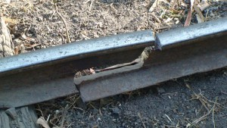
- An example of the rail fracture [17].
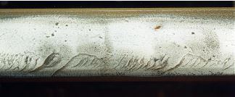
- An example of headcheck failure that occur in the rail [16].
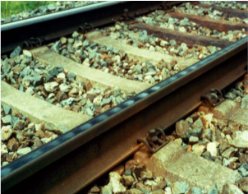
- An example of undulation defect that occur in the rail [14].
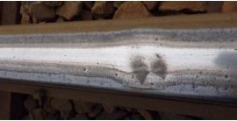
- An example of scour defect that can happen in the rail [16].
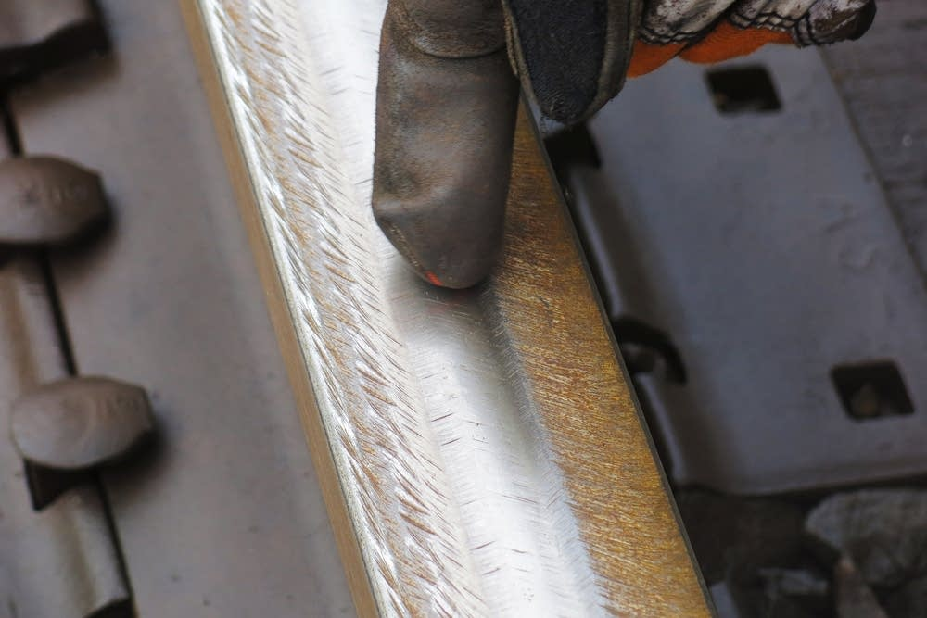
- An example of wear defect that can happen in the rail [18].
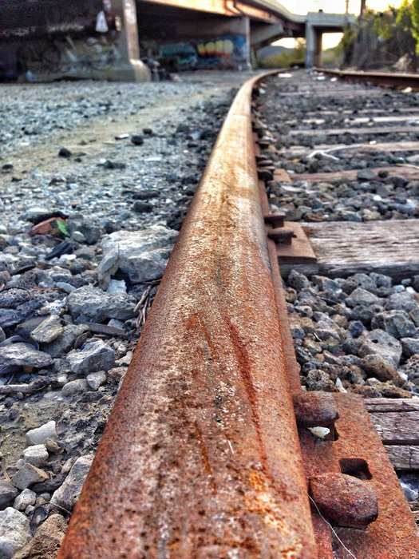
- An example of oxidation defect that can happen in the rail [19].

The Rail Defect Detection Methods
Many methods that detect rail surface defects exist in the literature. These methods employ contactless image processing techniques. So that the rail surface is not damaged. Besides, possible accidents are prevented by early detection of many rail failures. Rail fault detection methods that are frequently used in the literature are presented below.

Rail Damage Detection using Neural Networks
An onboard measurement system is done for measuring the rail robot’s excursions from the rails midlines and the rail-robot’s heights above the rail [1]. In this method, to deal with the nonlinearity of the measurement models, the coupling between the outputs, and the noise contamination, a neural network method is proposed for building high precision measurement models [1]. In addition to different measurement models for different types of rail tracks are also built based on the proposed neural network module. Signal processing and neural network module of the method used in [1] appear in Fig. 8.
- Signal processing and neural network module in [1].

Rail Fault Detection based on the Morphology of Multi-scale and Dual-Structure Elements
Heavy rail surface defects are detected based on the mathematical morphology of multi-scale and dual-structure elements according to the characteristics of heavy rail surface defects, uneven brightness and noise in [6]. When this method is compared with the traditional edge detection operators, the results show that this method owns strong anti-noise performance, can detect the small defect edge accurately under noise. Using the morphology of multi-scale and dual-structure elements, defects such as scratches, rolled-in scale, and uneven rolling on the rails are detected [6].

Rail Defect Detection using Gabor filters
In the [8], Binary Image Based Rail Extraction (BIBRE) algorithm is used to extract the rails from the background. The extracted rails are enhanced to achieve uniform background with the help of direct enhancement method [8]. The direct enhancement method enhance the image by enhancing the brightness difference between objects and their backgrounds [8]. The enhanced rail image uses Gabor filters to identify the defects from the rails. The Gabor filters maximizes the energy difference between defect and defect less surface. Thresholding is done based on the energy of the defects. From the thresholded image the defects are identified and a message box is generated when there is a presence of defects [8]. The faulty rail image taken as input and the faulty region detected are shown in Fig. 9 [8].
(a) Input image | (b) Output image
- The faulty rail image and detected defects[17].

Rail defect detection with images taken from two cameras
In the [9], the images are taken from two cameras, which of them are placed at different angles on the experimental setup. The preprocessing stage is made by applying OTSU method to obtained images [9]. The rail surface is determined by using Canny edge detection and Hough transform. Faults occurred on the rail surface are detected by combining images taken from two cameras [9]. The accuracy of the proposed method was increased by using the images taken from two different cameras [9].

Detection of Surface Defects Using Wavelets
The signature tunes identified from numerical simulations are validated by field measurements in [13]. These signature tunes are employed in automatic detection algorithm for squats [13]. For the investigated Dutch tracks, the power spectrum in the frequencies between 1060-1160Hz and around 300Hz indicate existence of a squat and also provide information of whether a squat is light, moderate or severe. The detection algorithm in [13] is based on scale averaged wavelet power. The averaging of the wavelet spectrum is performed at frequency bands related to squats [13]. The thresholds for detection of squats on Dutch track are obtained empirically [13].

Detection of Rail Faults using Morphological Feature Extraction
An algorithm using Morphological feature extraction based image processing is offered in order to determine the breakdowns of rails in [10]. The rail is determined through applying the image processing methods and Hough transform to the received images of rail [10]. Head check breakage, apletilic and undulation of defects are determined by method in [10]. Faulty regions is determined through extracting features of regions in images by applying Morphological operations to detected rail images [10]. In [10], all steps of the offered method is applied to the images of rail under different direction and lighting.

Comparison Study of The Rail Defect Detection Methods ın The Literature
Studies in [1], [6], [8], [9], [10], and [13] have been compared in several respects. These respects are algorithm's accuracy rate and operation time, feasibility, techniques used in fault detection, detectable failures, hardware resource requirement, used software development environments, and images used in the algorithm. The advantages and disadvantages of these algorithms relative to each other are given in the following table.

- A COMPARISON OF THESE METHODS IN LITERATURE
Study in the literature | Techniques used in fault detection | Detectable failures | Hardware resource requirement | Used software development environments | Feasibility | Algorithm's performance criteria
[1] | Neural Networks  Proximity Sensors  Levenburg-Marquart algorithm  Signal Processing | Detect nonlinearity of the measurement models (defects) | Hardware required (Proximity Sensors) | - | High | High accuracy rate
[6] | Mathematical morphology of multi-scale  Dual-structure elements  Edge detection algorithms | Scratch defect  Backfin defect  Uneven rolling  Rolled-in scale | Hardware required  (CCD Camera) | - | Medium | Strong anti-noise performance  Peak signal to noise ratio is 24.5 dB
[8] | Binary Image Based Rail Extraction (BIBRE) algorithm  Gabor filters  Thresholding  Texture analysis | Scour defect | Hardware required  (Digital camera of 12 megapixels) | Matlab | High | Accuracy rate 89.9%
[9] | Otsu method  Canny edge detection  Hough transform  Gauss Filter | Wear defect | Hardware required  (Special light sources and laser camera) | Matlab | High | 84.3 millisecond elapsed time  Standard deviation 1.5  The approximate speed of the system for 1 frame is 12fps
[10] | Morphological feature extraction  Hough transform  Edge detection  Laplacian filter  Gradient computing | Headcheck defects  Breakage defects  Apletilic defects  Undulation defect | No hardware required | Matlab | Medium | 0.6 sec.  Accuracy rate 85.3%
[13] | Axle box acceleration (ABA) measurements  Wavelet power spectrum  Low-pass filtering | Squats defect | No hardware required | - | Medium | Accuracy rate  78% for light squats  100% for severe squats

The algorithms in the literature are superior and weak to each other. It is suitable for on-line rail damage detection and measurement applications in [1]. Moreover different measurement models for different types of rail tracks are also built based on the in [1] neural network module. To deal with the nonlinearity of the measurement models, the coupling between the outputs and the noise contamination, a neural network method is proposed for building high precision measurement models in [1].
When studies in [9] and [10] are compared, study in [9] is superior to study in [10] in terms of elapsed time. Study in [10] is superior to study in [9] in terms of the type of failure detected. When studies in [6] and [13] are compared, study in [6] is superior to study in [13] in terms of the type of failure detected and study in [6] is weak according to study in [13] in terms of the hardware required. The number of failures detected among comparative methods is at most [10]. Superiority of method in [6] over other methods is that this method owns strong anti-noise performance. While the advantage of algorithm in [8] among other tasks is that the enhanced image has uniform background and defects highlighted from the illuminated background, the advantage of algorithm in [9] among other tasks is that failures on the track surface can be clearly identified by combining images taken from two cameras. The implementation in [13] has been checked with the real-life tests in the Netherlands.

Acknowledgment
This work has been supported by TUBİTAK (The Scientific and Technological Research Council of Turkey). Project Number: 114E202

Reference
- Z.G. Hou, and M. M. Gupta, “A rail damage detection and measurement system using neural networks.”, 2004 IEEE International Conference on. IEEE, Computational Intelligence for Measurement Systems and Applications, 2004. CIMSA, 2004.
- Q. Li, and S. Ren, “A visual detection system for rail surface defects.”, IEEE Transactions on Systems, Man, and Cybernetics, Part C (Applications and Reviews) Vol. 42.6 ,pp. 1531-1542, 2012.
- B. Sambo, A. Bevan, and C. Pislaru, “A novel application of image processing for the detection of rail surface RCF damage and incorporation in a crack growth model.”, The International Conference on Railway Engineering (ICRE) 2016, pp.1-9 , doı. 10.1049/cp.2016.0521, 2016.
- Z. Mao, Y. Zhan, G. Tao, B. Jiang, and X.G. Yan, “Sensor Fault Detection for Rail Vehicle Suspension Systems with Disturbances and Stochastic Noises”, IEEE Transactions on Vehicular Technology, Vol. PP, Issue 99, pp. 1-1, doı: 10.1109/TVT.2016.2628054, 2016.
- S. Faghih-Roohi, S. Hajizadeh, A. Núñez, R. Babuska, B. D. Schutter, “Deep Convolutional Neural Networks for Detection of Rail Surface Defects”, 2016 International Joint Conference on Neural Networks (IJCNN), pp. 2584-2589, doı: 10.1109/IJCNN.2016.7727522, 2016.
- G. Hu, L. Xiong, and J. Tang, “Heavy rail surface defects detection based on the morphology of multi-scale and dual-structure elements.”, Chinese Automation Congress (CAC), 2015. IEEE,pp. 2126 - 2129, DOI: 10.1109/CAC.2015.7382856, 2015.
- S. Li, X. Wei, and L. Jia, “Surface defects detection of railway turnouts.”, Control Conference (CCC), 2015 34th Chinese. IEEE, pp. 6285 - 6290, DOI: 10.1109/ChiCC.2015.7260626, 2015.
- V. R. Vijaykumar and S. Sangamithirai, “Rail Defect Detection using Gabor filters with Texture Analysis”, 2015 3rd International Conference on Signal Processing, Communication and Networking (ICSCN), pp. 1 - 6, DOI: 10.1109/ICSCN.2015.7219838, 2015.
- O. Yaman, M. Karaköse, E. Akın, and İ. Aydın, “Image Processing Based Fault Detection Approach for Rail Surface”, 2015 23nd Signal Processing and Communications Applications Conference (SIU), pp. 1118 - 1121, DOI: 10.1109/SIU.2015.7130031, 2015.
- C. Tastimur, E. Akın, M. Karaköse, and İ. Aydın, “ Detection of rail faults using morphological feature extraction based image processing”, 2015 23nd Signal Processing and Communications Applications Conference (SIU), pp. 1244 - 1247, DOI: 10.1109/SIU.2015.7130063, 2015.
- L. Jie, L. Siwei, L. Qingyong, Z. Hanqing, and R. Shengwei, “Real-time Rail Head Surface Defect Detection: a Geometrical Approach”, 2009 IEEE International Symposium on Industrial Electronics, pp. 769 - 774, DOI: 10.1109/ISIE.2009.5214088, 2009.
- Q. Wei, X. Zhang, Y. Wang, N. Feng, and Y. Shen, “Rail defect detection based on vibration acceleration signals”, Instrumentation and Measurement Technology Conference (I2MTC), 2013 IEEE International. IEEE, pp. 1194 - 1199, DOI: 10.1109/I2MTC.2013.6555602, 2013.
- M. Molodova, Z. Li, A. Núñez and R. Dollevoet, “Monitoring the Railway Infrastructure: Detection of Surface Defects Using Wavelets”, Proceedings of the 16th International IEEE Annual Conference on Intelligent Transportation Systems (ITSC 2013), The Hague, The Netherlands, October 6-9, 2013.
- Y. Santur, M. Karaköse and E. Akın, “Random Forest Based Diagnosis Approach for Rail Fault Inspection in Railways”, in The 9th International Conference on Electrical and Electronics Engineering (ELECO 2015), pp. 714-719, Bursa, Turkey, 26-28 November, 2015.
- C. Taştimur, M. Karaköse, E. Akın, and İ. Aydın, “Rail defect detection with real time image processing technique”, 2016 IEEE 14th International Conference on Industrial Informatics (INDIN), pp. 411 - 415, DOI: 10.1109/INDIN.2016.7819194, 2016.
- R.P.B.J. Dollevoet, Design of an Anti Head Check profile based on stress relief, University of Twente, 2010.
- Rail System Net, (2015), “Derailment”. [Online]. Available: http://www.railsystem.net/derailment/
- MPRNews, (December, 2015), “MN rail inspector's quest: Find the flaws, stop a future accident”. [Online]. Available: https://www.mprnews.org/story/2015/12/28/minnesota-rail-inspector
- Chapter My Chicago, (2014), “The Oxidation Rail”. [Online]. Available: http://www.capturemychicago.com/users/stackstack60

