Synthesis, Structural and Thermal Characterizations and In vitro Cytotoxic Activities of New Cyclotriphosphazene Derivatives
Kenan Koran^{1,}*, Çiğdem Tekin², Eray Çalışkan³, Suat Tekin⁴, Süleyman Sandal⁴, Ahmet Orhan Görgülü¹
¹Firat University, Faculty of Science, Department of Chemistry Elazığ, Turkey
²Department of Public Health, Faculty of Medicine, Inonu University, Malatya, Turkey
³Bingol University, Faculty of Science, Department of Chemistry Bingöl, Turkey
⁴Inonu University, Faculty of Medicine, Department of Physiology, Malatya, Turkey
Email: kkoran@firat.edu.tr
Supplemental Materials
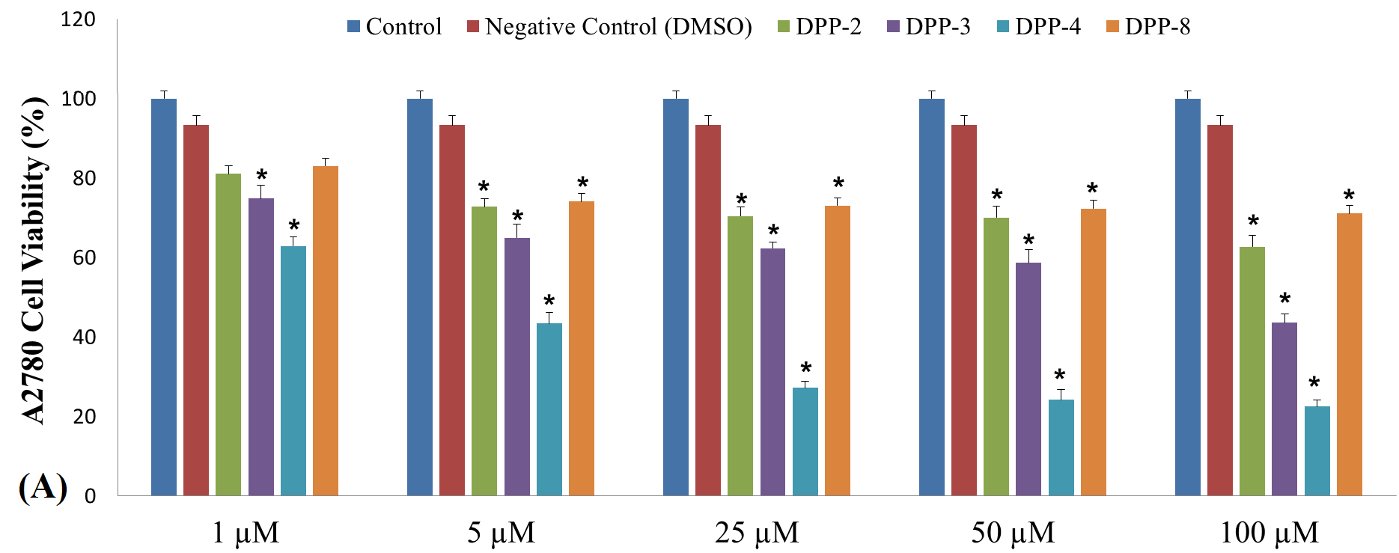
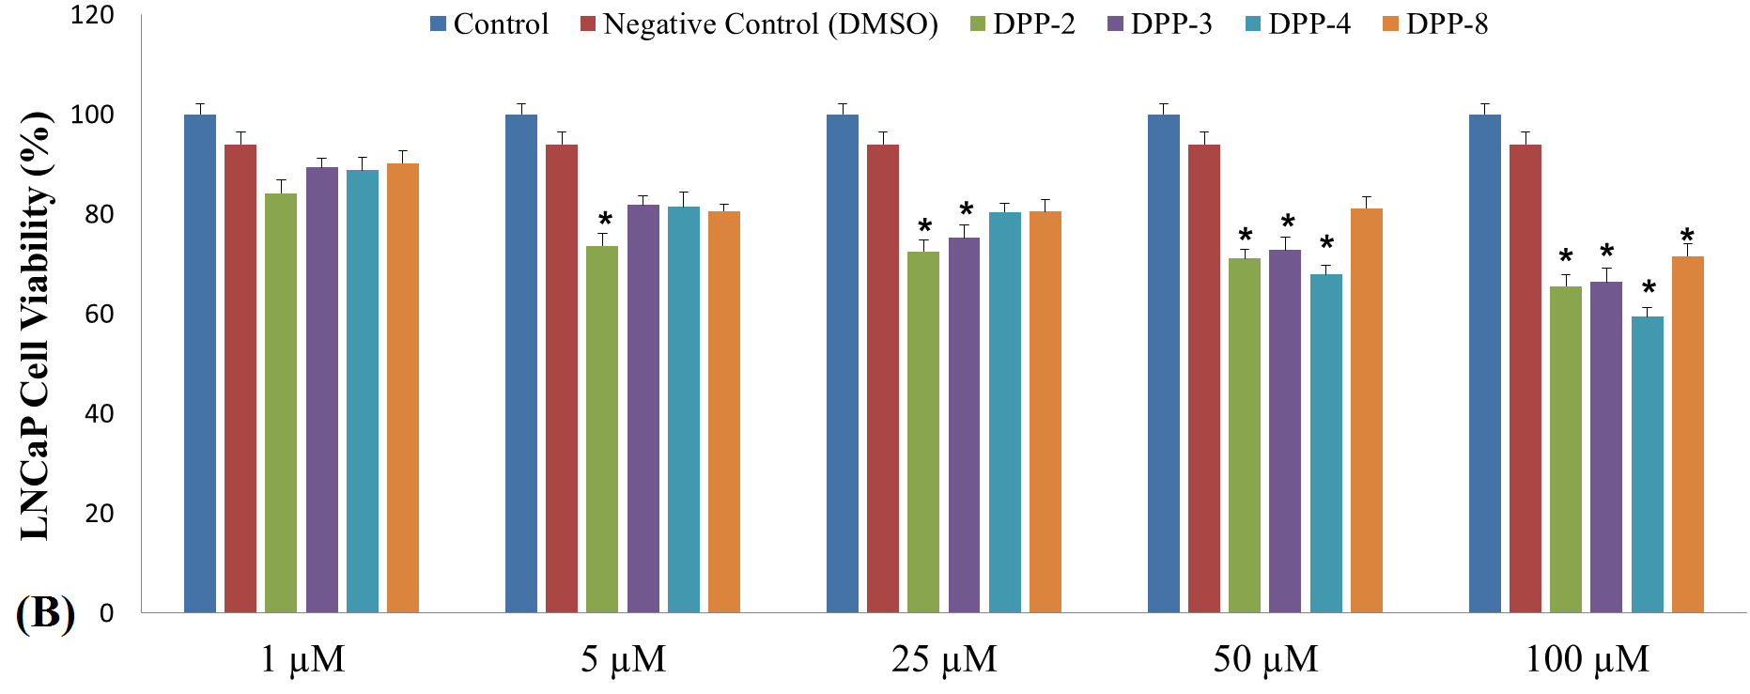
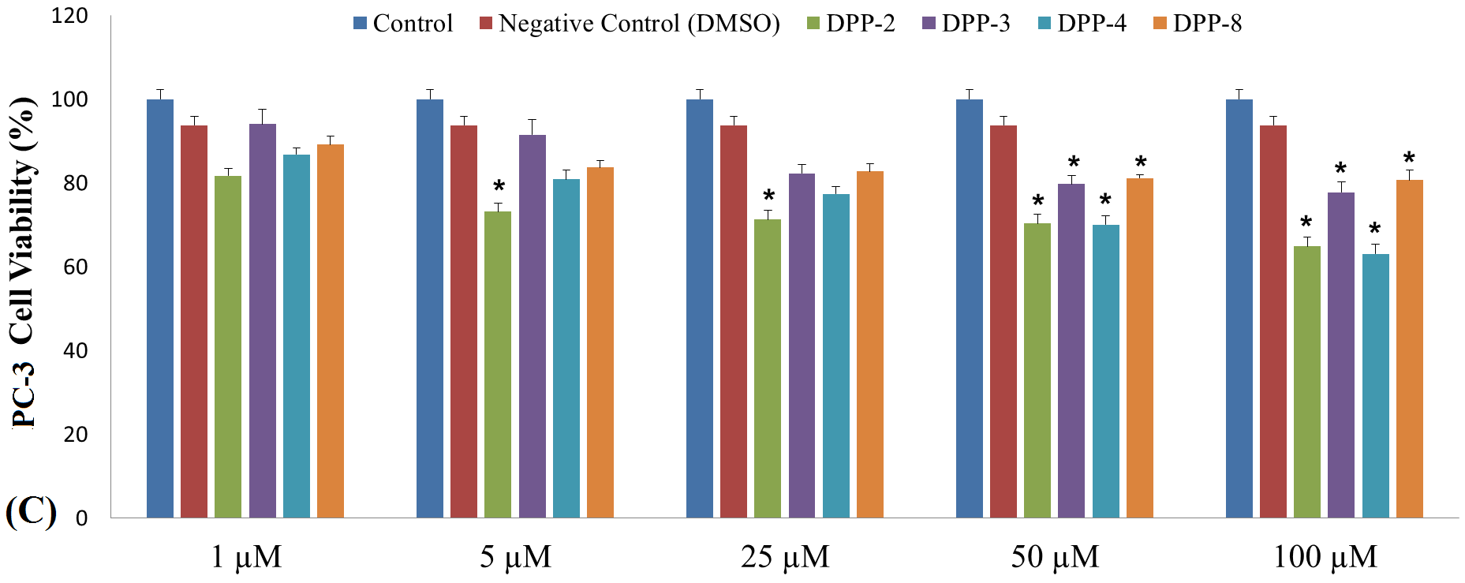
Figure S 1. The relative cell viability (%) of A2780 (A), LNCaP (B) and PC-3 (C) cells after a 24-hour treatment with all the compounds DPP-2, DPP-3, DPP-4 and DPP-8. The changes on the cell viability (%) caused by compounds DPP-2, DPP-3, DPP-4 and DPP-8 are compared with the negative control data. Each data point is an average of 10 viability (*p<0.05).
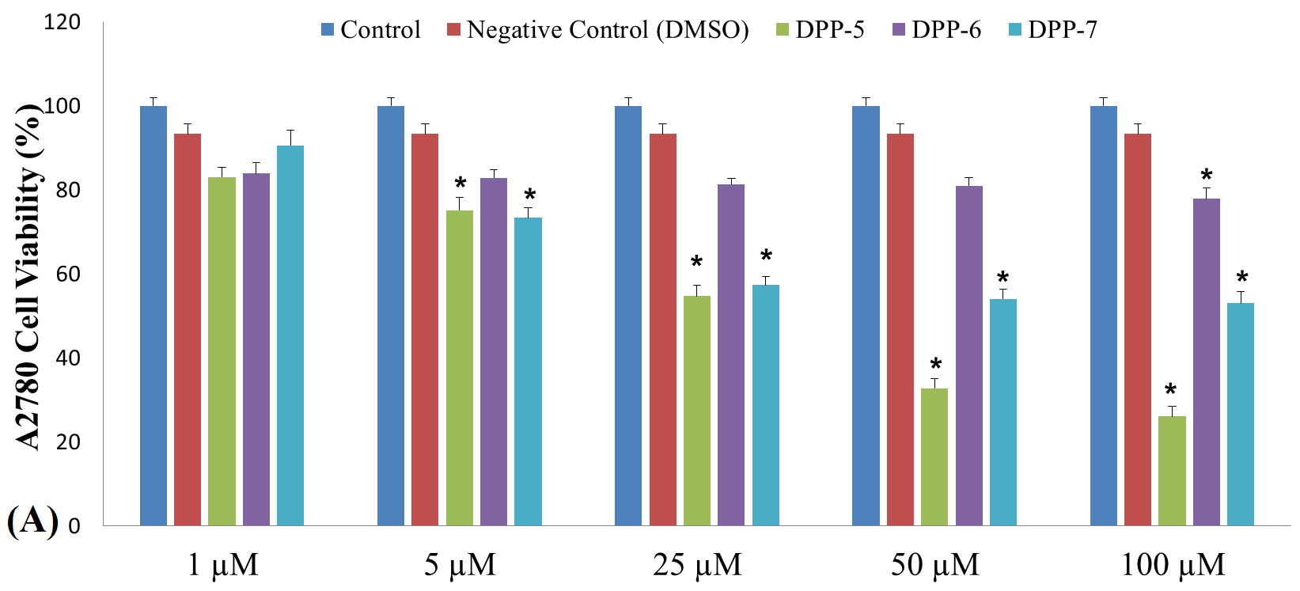
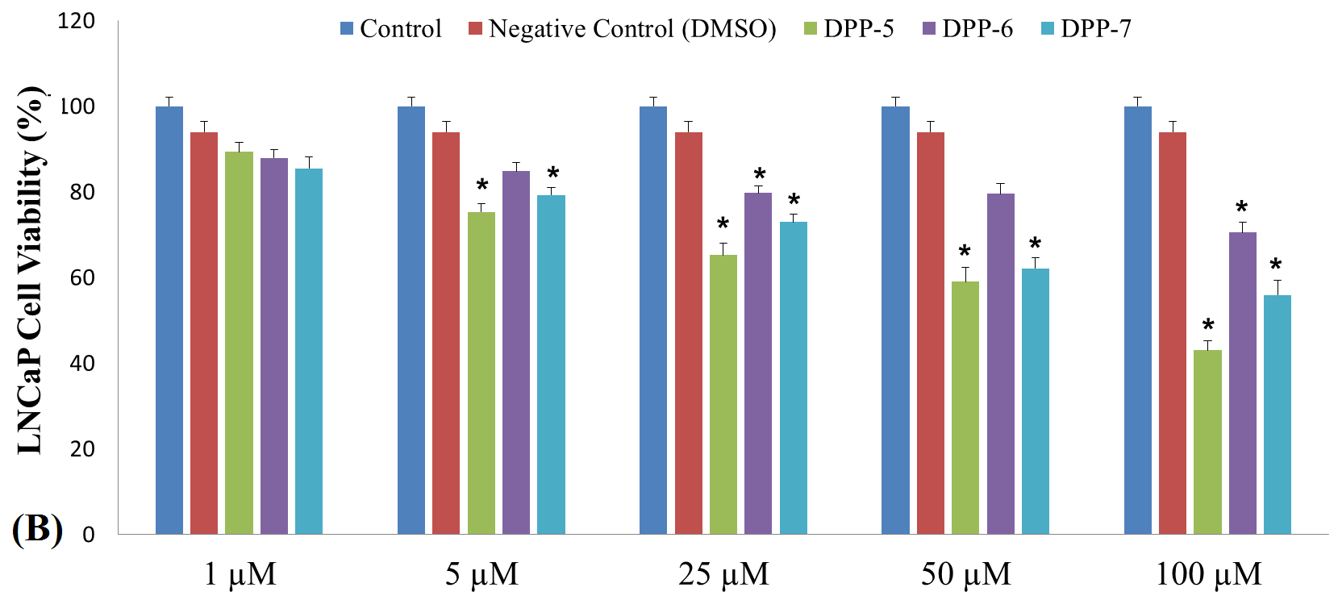
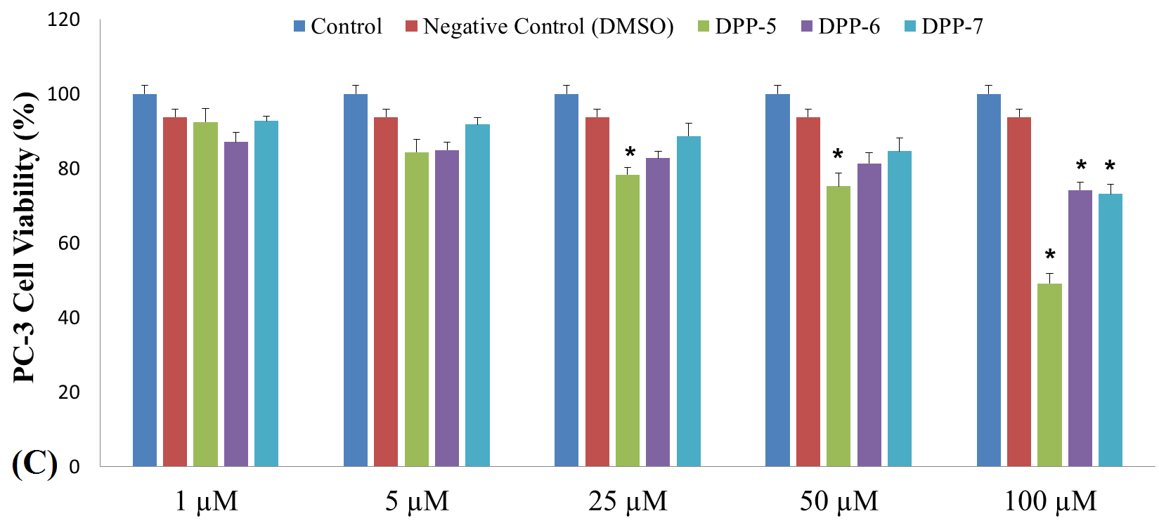
Figure S 2. The relative cell viability (%) of A2780 (A), LNCaP (B) and PC-3 (C) cells after a 24-hour treatment with all the compounds DPP-5, DPP-6 and DPP-7. The changes on the cell viability (%) caused by compounds DPP-5, DPP-6 and DPP-7 are compared with the negative control data. Each data point is an average of 10 viability (*p<0.05).

Table S 1. TGA results and LogIC₅₀ values for compounds DPP 2-8.
TGA  results | Cyclotriphosphazene compounds
TGA  results | DPP 2 |  | DPP 3 |  | DPP 4 |  | DPP 5 |  | DPP 6 |  | DPP 7 |  | DPP 8
T_{i}/⁰Cª | 302 |  | 294 |  | 294 |  | 300 |  | 312 |  | 304 |  | 271
T_{50%}/⁰C^{b} | 703 |  | 580 |  | 643 |  | 647 |  | 666 |  | 688 |  | 693
Residue (%)  at 900 ⁰C | 17 |  | 5 |  | 0 |  | 2.5 |  | 0 |  | 0 |  | 21.5
LogIC₅₀ values | LogIC₅₀ values (µM) of compounds DPP 2-8 against a panel of three cancer cell lines. LogIC₅₀ is the half maximal effective concentration of drug that reduces cell growth by 50%.
LogIC₅₀ values | DPP 2 | DPP 3 |  | DPP 4 |  | DPP 5 | DPP 6 | DPP 7 |  | DPP 8 |  | Docetaxel |  | Cisplatin
A2780 | 2.04 | 1.72 |  | 0.62 |  | 1.41 | 1.88 | 1.75 |  | 2.16 |  | - |  | -0.186
PC-3 | 2.07 | 2.39 |  | 2.10 |  | 2.02 | 2.30 | 2.41 |  | 2.44 |  | -0.213 |  | -
LNCaP | 2.09 | 2.14 |  | 2.06 |  | 1.77 | 2.29 | 1.94 |  | 2.30 |  | -0.213 |  | -
ª Initial decomposition temperature
^{b} Decomposition temperature at 50 % mass loss

